## **Design:**

## use case

## Figure 1. use case diagram high level

## C:\Users\CTEA\AppData\Local\Microsoft\Windows\INetCache\Content.Word\flow.png

## Figure 2. Activity diagram high level

## C:\Users\CTEA\AppData\Local\Microsoft\Windows\INetCache\Content.Word\bd(1).png

## Figure 3 Component Diagram High Level

## class diagram (3)

## Figure 4 Class Diagram High Level

## C:\Users\CTEA\AppData\Local\Microsoft\Windows\INetCache\Content.Word\bbd

## Figure 5. use case diagram low level

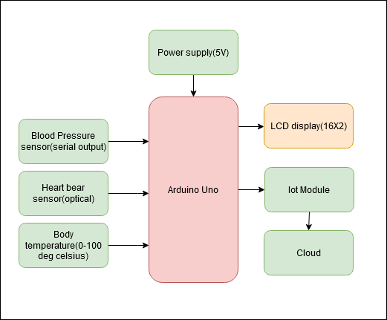

## Figure 6 component Diagram Low Level

## class diagram (2)

## Figure 7 Class Diagram High Level